Module-2
Operators in C, Type conversion and typecasting and Decision control and looping statements

Operators in C: In C language we can formulate different types of expressions based on operators used. Various important operators available in C language are:
1. Arithmetic Operators 6. Bitwise Operators
2. Relational Operators 7. Conditional operator
3. Logical Operators 8. Size of operator
4. Assignment Operators 9. Comma operator
5. Equality operators 10. Unary operator

1. Arithmetic operator: C provides all basic arithmetic operators.
Here is a brief summary of different operators.

Arithmetic Operator

Name Example

+ Addition or unary plus C=A+B
- Subtraction or unary minus Z=X-Y
* Multiplication R=P*Q
/ Division (The result given is Quotient) S=P/Q
% Modular division (The result given is remainder) Note: modular operation is possible only on integer data types
D=A%B Here A and
B should
be integers

Arithmetic expressions are of three types:
1. Integer Arithmetic
2. Real Arithmetic
3. Mixed mode Arithmetic

Integer Arithmetic: It is an expression evaluation where all the operands are of integer data type. Let us take an example.
int a=10,b=5,c;
c=a/b;
printf(“%d”,c);
c will contain quotient value
Real Arithmetic: It is an expression evaluation where all the operands are of float data type.
example:
float x=2.5, y=10.0, z;
z=y/x;
printf(“%f”, z);
z will contain value 4.000000

Mixed Mode Arithmetic: In an expression if some operands are of integer type and others are of float type it is called mixed mode arithmetic expression. Here the data type of small size gets automatically converted to data type of bigger size.
Ex: a=25;
float x=4,z; z=a/x;
printf(“%f”,z);
Here, “a” is of integer data type and “x” is of float type, therefore “a” automatically gets converted to float type
and output is:6.25

2. Relational operator: Relational operators are often used to compare two quantities on their relation, take certain decision. An expression that uses relational operators are called relational expressions. The value of relational expression is either 1 or 0. 1 means true, 0 means false. C supports 4 relational operators.

Relational operators | Name | Example
> | Greater Than | A>B
< | Less Than | X<Y
>= | Greater Than or Equal to | (A+B) >=(X-Y)
<= | Less Than or Equal to | (P+Q)<=(R-S)

3.Logical operator: Logical operators are used to test more than one condition mad
make decision. C provides 3 logical operators as shown below.

The truth table of Logical operators is as follows:

&&(Logical AND operator) |  |  | || (Logical or operator) |  |  | !(Logical NOT operator)
A | B | A&&B | A | B | A||B | A | !A
0 | 0 | 0(False) | 0 | 0 | 0 | 0(False) | 1(True)
0 | 1 | 0(False) | 0 | 1 | 1 | 1(True) | 0(False)
1 | 0 | 0(False) | 1 | 0 | 1
1 | 1 | 1(True) | 1 | 1 | 1

Note: 1. In Logical AND operator output is TRUE only if both inputs are TRUE.
2. In Logical OR operator output is TRUE if any of the inputs are TRUE.
3. In Logical NOT operator output is TRUE if input is FALSE and vice versa. Here are some examples on logical expressions: Example1: int A=5, B=10, X=20, Y=5;
What is truth value of expression: ( A ) && ( B )? (5) && (10) both are non-zero
number: 1 && 1= 1 (True) (Note: Any non-zero number is treated as1)

4. Assignment operators (=): Assignment operators are used to assign the result of an expression to a variable. There are three types of assignment
1. Simple assignment. Ex a=5;
2. Shorthand assignment. Ex a+=5;
3. Multiple assignments Ex a=b=c=100;
An expression such as i =i+2; in which the variable on the left side is repeated immediately on the right, can be written in the compressed form i += 2;
The operator += is called a shorthand assignment operator.
Note: the left-hand side of the assignment operator should always have variable.
a+b=5 is illegal operator.

5. Unary operators: Unary operators act on single operands. C language supports three unary operators such as unary minus, increment and decrement. The operator ++ adds 1to the operand and - - subtract 1. Both are unary operator and takes the form.
Unary minus: Unary minus (-) operator is strikingly different from the binary arithmetic operator that operates on two operands and subtracts the second operand from the first operand. When the operand is preceded by a minus sign, the unary operator negates its value. For example, if a number is positive then it becomes negative when preceded with a unary minus operator. Similarly, if the number is negative, it becomes positive after applying the unary minus operator.
For example:
int a, b=10;
a = -(b);
The result of this expression is a = -10.
Increment operator(++) and Decrement operator(--):
The increment Operator is a unary operator that increases the value of its operand by 1. Similarly, the decrement operator decreases the value of its operand by 1.
Example: m++; equivalent to m=m+1
m--; equivalent to m=m-1
The increment/decrement operators have two variants prefix and postfix.
In a prefix expression (++m or --m), the operator is applied before an operand is fetched for computation and thus, the altered value is used for the computation of the expression in which it occurs. On the contrary, in a postfix expression (m++ or m--) an operator is applied after an operand is fetched for computation of the expression in which it occurs.
These are extensively used in loops (while, for, do while) Ex: int x = 10, y;
y= x++; is equivalent to y = x;
x=x+1;
whereas, y=++x;
is equivalent to writing
x= x+1;
y=x;

6.Bitwise operators: C has a distinction of supporting special operator known as bitwise operators for manipulation of data at bit levels. These operators are used for testing the bits, or shifting them right or left. Bitwise operators may not be applied to float or double.

Table below shows bitwise operators and their meaning.

Bitwise operators | Meaning | Examples
& | Bitwise AND | A & B
| | Bitwise OR | X | Y
>> | Bitwise Right shift | P >>2
<< | Bitwise Left Shift | Q<<2
^ | Bitwise ones | X ^ Y
~ | Bitwise complement | ~5

Examples for bitwise AND, OR and XOR:
A B A & B A | B A^B
0 0 0 0 0
0 1 0 1 1
1 0 0 1 1
1 1 1 1 0

Example for Bitwise Left shift:
A 0 1 0 0 0 1 1 0
A<<2 0 0 0 1 1 0 0 0

Note: Meaning is to left shift bits by 2 positions
Example for Bitwise Right shift:
A 0 1 0 0 0 1 1 0
A>>2 0 0 0 1 0 0 0 1

Note: Meaning is to right shift bits by 2 positions.

7. Conditional Operators[?:] Or Ternary Operator
1. They are also called as Ternary Operator.
2. It takes 3 Arguments as shown in the syntax:

Where:

Expression 1 ? Expression 2 : Expression 3
Expression 1 is Condition ,
Expression 2 is Statement Followed if Condition is True
Expression 3 is Statement Followed if Condition is False

Meaning of Syntax:
1. Expression1 is nothing but Boolean Condition i.e it results into either TRUE or FALSE
2. If result of expression1 is TRUE then expression 2 is executed.
3. Expression1 is said to be TRUE if its result is NON-ZERO
4. If result of expression1 is FALSE then expression3 is executed
5. Expression1 is said to be FALSE if its result is ZERO

Example : Check whether Number is Odd or Even
#include<stdio.h>
void main()
{
int num;
printf("Enter the Number : ");
scanf("%d",&num);
flag ((num%2==0)?1:0);
if(flag==1)
printf("\n Even"); else
printf("\n Odd");

}

8) Comma Operator

Example:
Comma operator has lowest precedence. [Priority] i.e., evaluated at last.
1. Comma operator returns the value of the rightmost operand.
2. Comma operator can acts as
- Operator: In the Expression
- Separator: Declaring Variable,
- In Function Call Parameter List
#include<stdio.h>
void main()
{

Output: 2
int a=1,b=2;
int k;
k = (a,b);
printf("%d",k);
}
Different Typical Ways of Comma as Operator :
int a=1,b=2,c; Way 1 :
c = (a , b);
c = Value Stores in b = 2
Way 2 :
c = a , b;
c = Value Stores in a = 1

9. Size of () operators: It is a compile time operator and when used with an operand it returns the number of bytes the operand occupies the operand may be variable or constant or data type qualifier.

Example:
int a = 10;
int result;
result= sizeof(a);
output: result=2.
10. Equality operators: C language supports two kinds of equality operators to compare their operands for strict equality or inequality.
They are equal to(==) and not equal to(!=) operators.
The equality operators have lower precedence than the relational operators.

The equal to operator (==) returns true(1) if operands on both the sides of the operator have the same value; otherwise, it returns false(0). On the contrary, the not equal-to operator (!=)
returns true(1) if the operands do not have the same value; else it return false(0).
operator Meaning
= = Return 1 if both operands are equal, 0 otherwise
! = Returns 1 if operands do not have the same value, 0 otherwise

Operator Precedence and Associativity:
In previous section we came across expressions and various operators used in an expression.
For instance if an expression consists of different category of operators such expression is evaluated using Precedence (priority) of operators and Associativity of operators.

Precedence: The order in which the operators in a complex expression are evaluated is determined by set of priorities known as precedence. If an expression contains Arithmetic operators „+‟ , „*‟ and „/ „operators as shown below:
A=B+C*D/F
In this expression RHS of expression contains B+C*D/F, here first preference is given to „*‟
and „/ „and then to „+‟. This is decided by operator precedence given in C Language.

Let us say: B=5, C=7, D=9 and F=3, then value of A is: A=
5+7*9/3
This expression is evaluated in following steps: A= 5 +(7*9)/3A
A =5+(63/3) A=5+21
A=26

Evaluation of Expressions:
Based on the Precedence and Associativity of operators here we discuss evaluating various types of
expressions. int a=10, b=7, c=8, d=2;
– a + b / c - d

2 1 3

10 + (7/8) – 2 (10+ 0) - 2
(10 – 2)
8

Note: In this example 7/8 gives 0 as answer as it is integer division the decimal portion is truncated.
Example-2:
int a=10, b=7, c=8, d=2;

– a + b && c - d

3
1 2
(10+7) && 8-2 (17) && (8-2)
(17) && (6)

Answer: TRUE(1)

Note: Any non-zero number is treated as 1 (TRUE) whenever Logical operators are used.

Example-3:
int a=10, b=7, c=8, d=2;

(a+b)* (c-d)

1 2

3

(10+ 7) * (8-2)

1 2

(17) *(6)=102

Type Conversion and Type casting

Type conversion or typecasting of variables refers to changing a variable of one data type into another. Type conversion is done implicitly whereas, typecasting has to be done explicitly by the programmer.

Type Conversion: Type conversion is done when the expression has variables of different data types. To evaluate the expression, the data type is promoted from lower to higher level.
Type conversion is automatically done when we assign an integer value to a floating point variable.
Consider the code given in which an integer data type is promoted to float. This is known as promotion(when a lower level data type is promoted to a higher type).
That is: char->int->long int->float->double->long double
Example:
int a=25; float x=5, z; z=x/a; printf(“%f”, z);

In this example “x” is float and “a” is integer, a gets automatically converted to float and answer is: z= (5.0/25.0)=0.2

The following changes that are unavoidable when performing type conversions.
- When a float value is converted to an integer value, the fractional part is truncated.
- When a double value is converted to a float value, rounding of digits is done.
- When a long int is converted into int, the excess higher order bits are dropped.
These changes may cause incorrect results.

Typecasting
Typecasting is also known as forced conversion. Typecasting an arithmetic expression tells the compiler to
represent the value of the expression in a certain way. It is done when the value of a higher data type has to be converted in to the value of a lower data type. But this cast is under the programmer’s control and not under compiler’s control.
Example:
float salary = 10000.00;
int sal;
sal=(int) salary;
When floating point numbers are converted to integers the digits after the decimal are truncated. Therefore, data is lost when floating-point representations are converted to integral representations. So in order to avoid such type of inaccuracies, int type variables must be typecast to float type.
Ex: int = 500, b= 70;
float res;
res = (float) a/b;
Another example of side effects in type conversions is here:
Example: float a=25, b=4;
int x;
x=a/b;

The problem here is though 25.0/4.0 will result in 6.25, it is stored in an integer variable „x‟. As a
result 6.25 is truncated to 6! Therefore we have to be careful when mixed data types are used.

1.Introduction: Decision control and Looping statements

Decision control and Looping statements C language possesses such decision making capabilities by supporting the following statements:
1. If statement
2. If-else statement
3. If-else-if statement
4. Switch statement

- These statements are popularly known as decision making statements. Also known as control statements.

2. DECISION MAKING (Two-Way Selection Statements)

- The basic decision statement in the computer is the two way selection.
- The decision is described to the computer as conditional statement that can be answered TRUE or FALSE.
- If the answer is TRUE, one or more action statements are executed.
- If answer is FALSE, the different action or set of actions are executed.
- Regardless of which set of actions is executed, the program continues with next statement.
- C language provides following two-way selection statements:

1. if statement
2. if – else statement
3. Nested if else statement

1. if statement: The general form of simple if statements is shown below.

if (Expression)
{
Statement1;
}
Statement2;

- The Expression is evaluated first, if the value of Expression is true (or non zero) then Statement1 will be executed; otherwise if it is false (or zero), then Statement1 will be skipped and the execution will jump to the Statement2.
- Remember when condition is true, both the Statement1 and Statement2 are executed in sequence. This is illustrated in Figure1.

Note: Statement1 can be single statement or group of statements.

Example:

#include<stdio.h>
void main( )
{

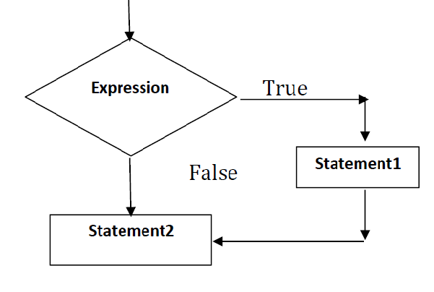
Figure 1: Flow chart of if statement
int a=20, b=11;
if (a >b)
{
printf(“a is bigger and value is= %d\n”, a);
}
printf(“job over\n”);
}

Output: a is bigger and value is=20
job over
2. if else statement: The if else statement is an extension of simple if statement.

General syntax:
if (Expression)
{

(true-block;) Statement1;
}

else

{

(false-block;) Statement2;
}

Statement3;

- If the Expression is true (or non-zero) then Statement1 will be executed; otherwise if it is false (or zero), then Statement2 will be executed.
- In this case either true block or false block will be executed, but not both.
- This is illustrated in Figure 2. In both the cases, the control is transferred subsequently to the Statement3.

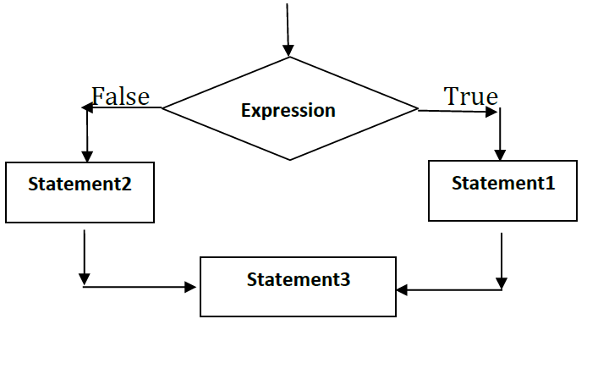

Figure 2: Flow chart of if-else state

Example:

void main( )
{
int a=10, b=11;
if (a >b)
{

printf(“a is bigger and value is =%d”, a);

}

else

{

Printf(“b is bigger and value is = %d”, b);

}
}

Output: b is bigger and value is=11

3. Nested if .. else statement: When a series of decisions are involved, we have to use more than one if..else statement in nested form as shown below in the general syntax.

if (Expression1) {
if(Expression2)
{ Statement1;
}
else

}

{ Statement2;
}
else if(Expression3)
{

else
Statement3;
}

{
Statement4;
}

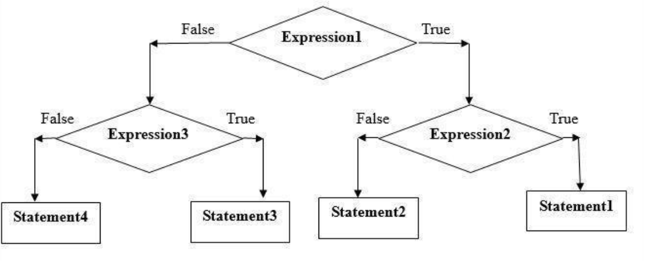

Figure 3: Flow chart of if-else-if(Nested if-else) statement

Example:
void main( )
{
int A=20, B=15, C=3;
if ( A>B)
{
if (A>C)
{
printf(“largest=%d”, A);
}
else
{
printf(“largest=%d”, C);
}
}
else
{
if(B>C)
{
printf(“ largest =%d”, B);
}
else
{
printf(“Invalid option”);
}
else
{
printf(“larges t=%d”, C);
}
}
}

Output: largest=20

3. SWITCH STATEMENT

- C language provides a multi-way decision statement so that complex else-if statements can be easily replaced by it. C language’s multi-way decision statement is called switch.
General syntax of switch statement is as fallows:

switch(choice)
{
case label1: block1;
break;
case label2: block2;
break;
case label3: block-3;
break; default
: default-block;
break;
}

- Here switch, case, break and default are built-in C language words.
- If the choice matches to label1 then block1 will be executed else if it evaluates to label2 then block2 will be executed and so on.
- If choice does not matches with any case labels, then default block will be executed.

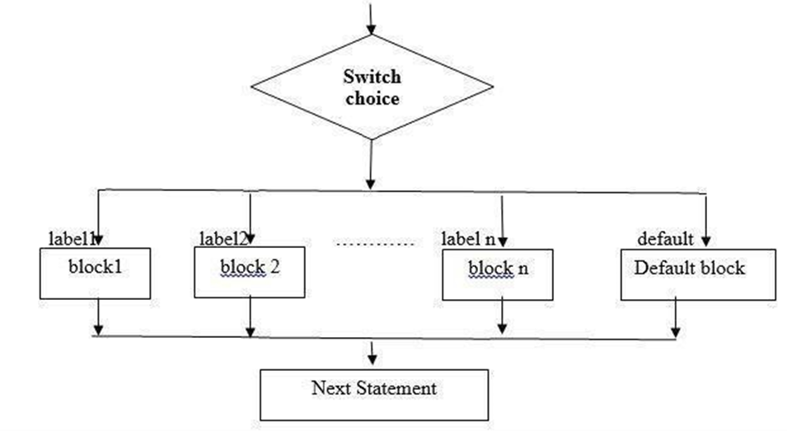

Figure 5: Flow chart of switch case statement

- The choice is an integer expression or characters.
- The label1, label2, label3,…. are constants or constant expression evaluate to integer constants.
- Each of these case labels should be unique within the switch statement. block1, block2, block3, … are statement lists and may contain zero or more statements.
- There is no need to put braces around these blocks. Note that case labels end with colon(:).
- Break statement at the end of each block signals end of a particular case and causes an exit from switch statement.
- The default is an optional case when present, it will execute if the value of the choice does not match with any of the case labels.

Example:

#include<stdio.h>

#include<stdlib.h>

void main( )

{
int ch,a,b,res;
float div;
printf(“Enter two numbers:”);
scanf(“%d%d”,&a,&b);
printf(“1.Addition\n 2.Subtraction\n 3.Multiplication\n 4.Division\n 5.Remainder”);

printf(“Enter your choice:\n”); scanf(“%d”,&ch); switch(ch)
{

case 1: res=a+b; printf(“Result=%d\n”,res); break;
case 2: res=a-b;

printf(“Result=%d\n”,res);

break;

case 3: res=a*b; printf(“Result=%d\n”,res); break;
case 4: div=(float)a/b;

printf(“Result=%f\n”,div);

break;

case 5: res=a%b;

printf(“Result=%d\n”,res);

break;

default: printf(“Wrong choice!!\n”);

exit(0);

Looping statements(iterative statements)

1. INTRODUCTION

Definition of Loop: It is a programming structure used to repeatedly carry out a particular instruction/statement until a condition is true. Each single repetition of the loop is known as an iteration of the loop.

Three important components of any loop are:

1. Initialization (example: ctr=1, i=0 etc)
2. Test Condition (example: ctr<=500, i != 0 etc)
3. Updating loop control values (example: ctr=ctr+1, i =i-1)

Pre-test and Post-test loops

- Loops can be classified into two types based on the placement of test-condition.
- If the test-condition is given in the beginning such loops are called pre-test loops (also known as entry-controlled loops).
- Otherwise if test condition is given at the end of the loop such loops are termed as post-test loops (or exit controlled loops).

Note Figure 1:
1. Here condition is at the beginning of loop. That is why it is called pre-test loop
2. It is also called as entry controlled loop because condition is tested before entering into the loop.
3. while is a keyword which can be used here.

Note Figure 2:
1. Here condition is at the end of the loop. That is why it is called post-test loop.
2. It is also called as exit controlled loop because condition is tested after body of the loop is executed at least once.
3. do and while are keywords which can be used here.

2. LOOPS IN C:

C language provides 3 looping structures namely:

1. while loop
2. do….while loop
3. for loop

The loops may be classified into two general types. Namely:
1. Counter-controlled loop
2. Sentinel-controlled loop

- When we know in advance exactly how many times the loop will be executed, we use a counter-controlled loop. A counter controlled loop is sometimes called definite repetition loop.
- In a sentinel-controlled loop, a special value called a sentinel value is used to change the loop control expression from true to false. A sentinel-controlled loop is often called indefinite repetition loop
i) while loop:
- It is a pre-test loop (also known as entry controlled loop). This loop has following
syntax:
while (condition)
{
statement-block;
}

- In the syntax given above ‘while’ is a key word and condition is at beginning of the loop.
- If the test condition is true the body of while loop will be executed.
- After execution of the body, the test condition is once again evaluated and if it is true, the body is executed once again.
- process is repeated until condition finally becomes false and control comes out of the body of the loop.

Flowchart

Here is an example program using while loop for finding sum of 1 to 10.

Example:

void main()
{
N=10; i=1; sum=0;
while (i<=N)
{ sum=sum+i; i=i+1;
}
printf(“%d”, sum);
}

Before loop execution: N=10, sum=0, i=1
First Round: N=10, sum=1, i=2

Second Round: N=10, sum=3, i=3

ii. do …. while lo op: It is a post-test loop (also called exit controlled loop) it has two keywords do and while. The General syntax:
Do
{
statement-block;
} while (condition);

- In this loop the body of the loop is executed first and then test condition is evaluated.
- If the condition is true, then the body of loop will be executed once again. This process continues as long as condition is true.
- When condition becomes false, the loop will be terminated and control comes out of the loop.

FLOWCHART:
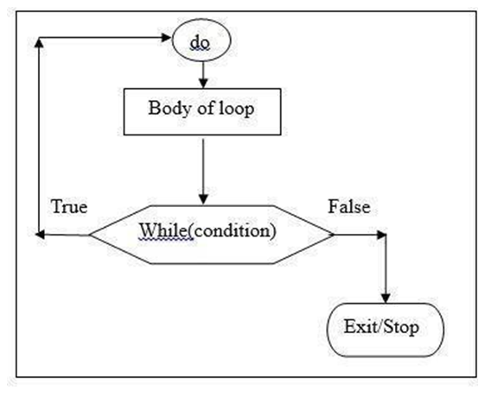

Example: The example already discussed with while loop to compute sum of 1 to 10 numbers is given here with do …while loop:

void main( )
{
N=10; i=1; sum=0;
do
{
sum=sum+i;
i=i+1;
}
while (i<=N);
printf(“%d”, sum);
}
Before loop execution: N=10, sum=0, i=1
First Round:

N=10, sum=1, i=2

Second Round:

N=10, sum=3, i=3

iii.for loop:
- It is another pre-test loop (also called entry controlled loop) that provides concise loop control structure. It has one keyword for.
- One important aspect of for loop is all the three components of a loop (viz. initializing, testing condition and updating (increment/decrement)) is given in the head of for loop

General syntax:

for( initialization; test-condition; updation)
{
Body-of loop;
}

The execution of for statement is as follows.

1. In this loop first initialization of control variable is done first, using assignments such as i=1, count=0. The variable i count are called loop control variable.
2. The value of control variable is tested using the test condition. The test condition is evaluated. If the condition is true, the body of the loop is executed; otherwise loop will be terminated.
3. When the body of the loop is executed, the control transferred back to the for statement to update the loop variable. And then condition is checked once again. If condition is true once again body will be executed once again. This process continues till the value of the control variable fails to satisfy the test condition.

Flowchart:

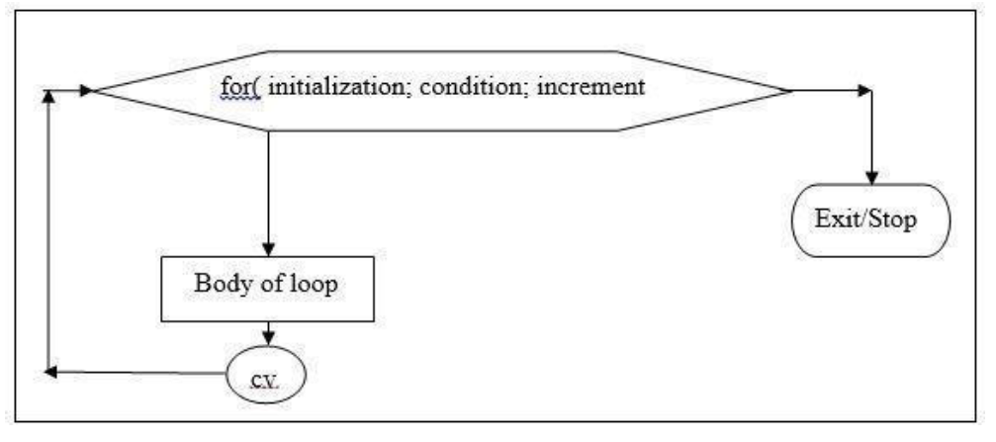


Example: Same program to find some of 1 to 10 numbers can be written using for loop as follows:

void main( )
{
int i, N=10, sum=0;

for (i=1; i<=N; i++)
{
sum=sum+i;
}
printf(“Total =%d”, sum);
}

Note: In for loops whether both i++ or ++i operations will be treated as pre-increment only.

Nested loops:
- In some programming situations within one for loop we have to write another for loop. Such embedded for loops are called nested for loops.
- Following diagram depicts a nested for loop flowchart.

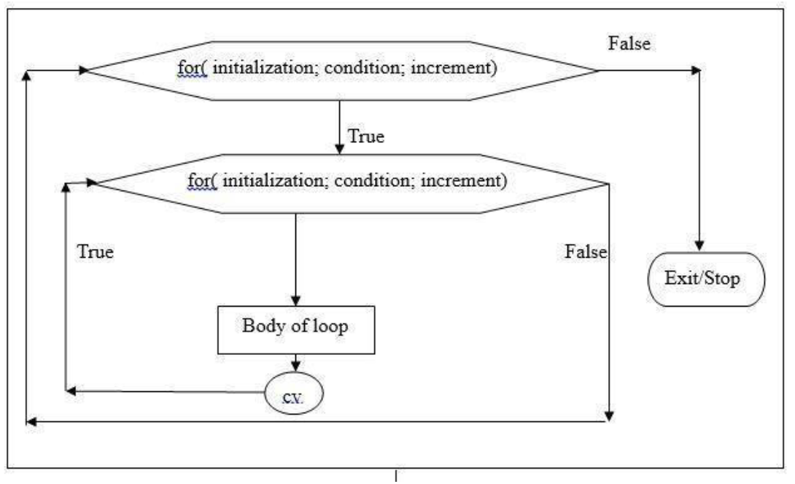

Example:

Here is an example program segment with sample outputs that illustrates the working of a nested for loop:

for(rows=1; rows<=4; rows++) for(cols=1;cols<=3; cols++)
{
printf(“%d %d”, rows, cols);
}

Working:
1. Initially value of rows=1 and 1 <=4 is true so control enters to inner loop
2. In inner loop cols=1 and 1<=3 is also true so body of the loop (i.e. printf gets executed)

Following are the outputs obtained in every repetition of inner/outer for loops:
Output:  1st round: | Output:  2nd round: | Output:  3rd round: | Output:  4th round:
rows=1,1,1 cols=1,2,3 | rows=2,2,2 cols=1,2,3 | rows=3,3,3 cols=1,2,3 | rows=4,4,4 cols=1,2,3

Initializing, Test condition and Updating: Three Components of a Loop
- Normally all loops should have three components:
1. Initialization (example: i=0; j=1 etc)
2. Test condition (example: ctr<=10, i<=20 etc)
3. Updating (example: ctr=ctr+1, i=i+2 etc)
- If any of these three components are missing program behaves indifferently. For instance if updating statement is missing loop goes into infinite mode as shown in following example:
void main( )
{
int ctr=1, N=10; while(ctr<=N)
{
printf(“Hello World\n”);

printf(“Hi Galaxy\n”);
}

}

Output: it prints, Hello world
Hello Galaxy

infinite number of times as ctr value remains 1 forever as

- Let us go through same example with initialization statement missing:

Example:
void main( )
{
int ctr, N=10; while(ctr<=N)
{
printf(“Hello World\n”);
printf(“Hi Galaxy\n”);
ctr=ctr+1;
}
}
Output: Loop will not at all get executed as initial value of ctr is unknown!
So program prints nothing.

3. JUMPS IN LOOPS
Break and continue: break and continue are unconditional control construct.
i. break
- This statement is useful to terminate a loop and transfer control out of loop under special situations.
- break statement works with while, do….while, for and switch statements.
- Following program syntax diagrammatically represents the working mechanism of break statement.
Void main()
{
While(condition1==true)

{
Statement1;
Statement2;
If(condition2==true)
{
break;
}
Statement4;
}
Statement5;
}
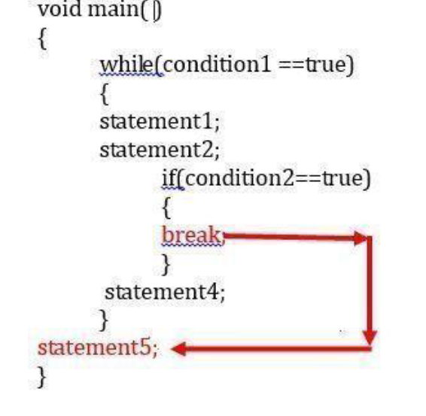
Note:
Working of continue statement:

When condition2 is true continue statement is executed which results in transfer of control
to beginning of while loop skipping statement4 and statement5.

Example program for continue statement:
void main()
{

int i;

for(i=1;i<=5;i++)
{

if(i==3)
break;
printf(“%d ”,i);
}
Output: 1 2

ii. Continue
- Statement is helpful to skip particular set of statements in loop body and to continue execution from the beginning of loop.
- Following syntax clearly depicts how control shifts to beginning of a loop on finding continue statement.

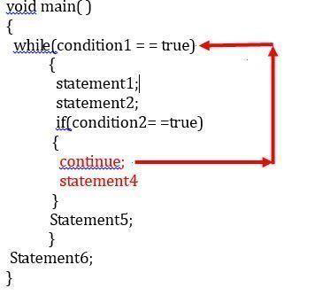

Note:
Working of continue statement:
When condition2 is true continue statement is executed which results in transfer of control to beginning of while loop skipping statement4 and statement5.
Example program for continue statement:
void main()
{
int i;
for(i=1;i<=5;i++)
{
if(i==3)
continue;
printf(“%d ”,i);
}
Output: 1 2 4 5

Goto statement
➢ goto is an unconditional branching statement. The syntax of goto is as follows:

goto label; statement1; statement2; label:
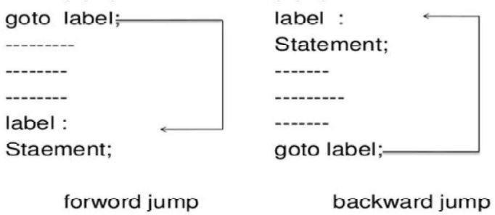
A label is a valid variable name.
➢ Label need not be declared and must be followed by colon.
➢ Label should be used along with a statement to which control is transferred.
➢ Label can be anywhere in the program either before or after the goto label.
➢ Here control jumps to label skipping statement1 and statement2 without verifying any condition that is the reason we call it unconditional jumping statement.

Example:

void main( )

{

int a=5, b=7; goto end; a=a+1; b=b+1;
end: printf(“a=%d b=%d”, a,b);

}
Computation of Binomial co-efficient

Problem: Binomial coefficients are used in the study of binomial distributions and readability of multicomponent redundant systems. It is given by:
B(m,x) =( 𝑚) = 𝑚! , m>=x
𝑋 𝑋!(𝑚−𝑋)!

A table of binomial coefficients is required to determine the binomial coefficient for any set of m and x.

Problem Analysis: The binomial coefficient can be recursively calculated as follows: B(m,0) = 1
B(m, x) = B(m, x-1)[𝑚−𝑋+1] , X = 1, 2, 3, …., m
𝑋

Further,

B(0, 0) = 1

That is, the binomial coefficient is one when either x is zero or m is zero. The program below points the table of binomial coefficients for m=10. The program employs one do loop and one while loop.

Program:

#include<stdio.h>
#define MAX 10 main( )
{
int m, x, binom;
printf(“ m x”);
for(m = 0; m <=10; ++m)
printf(%4d”, m);
printf(“\n ---------------------- \n”);
m = 0;
do
{

printf(“%2d”, m);
x = 0; binom = 1; while(x<=m)
{
If (m == 0 || x ==0) printf(“%4d”, binom); else
{
Binom= binom * (m-x +1) / x;
printf(“%4d”, binom);
}
x = x + 1;
}
printf(“\n”);
m=m+1;
}
while (m<= MAX);
printf(“ \n”);
}

OUTPUT:

mx 0 1 2 3 4 5 6 7 8 9 10
----------------------------------------------------------------------------------------------------------- --

0 1
1 1 1
2 1 2 1
3 1 3 3 1
4 1 4 6 4 1
5 1 5 10 10 5 1
6 1 6 15 20 15 6 1

7 1 7 21 35 35 21 7 1
8 1 8 28 56 70 56 28 8 1
9 1 9 36 84 126 126 84 36 9 1
10 1 10 45 120 210 252 210 120 45 10 1
----------------------------------------------------------------------------------------------------------
Pa sca l’s Triangle

➢One of the most interesting Number Patterns is Pascal's Triangle(named after Blaise Pascal, a famous French Mathematician and Philosopher).
➢To build the triangle, start with "1" at the top, then continue placing numbers below it in a triangular pattern.
➢Each number is the numbers directly above it added together.

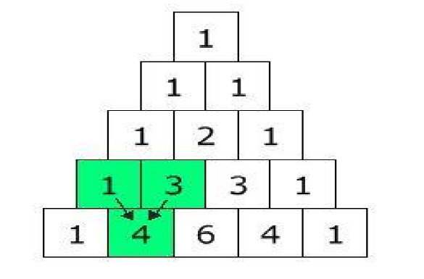


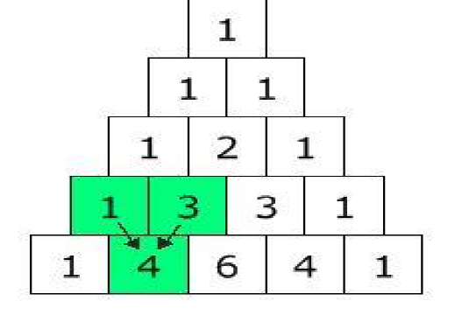

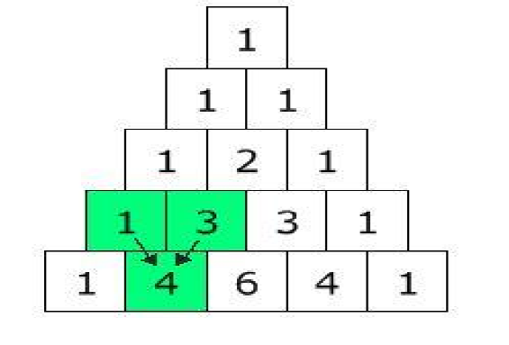





#include <stdio.h>
long factorial(int);
int main()
{
int i, n, c;
printf("Enter the number of rows you wish to see in pascal triangle\n");
scanf("%d",&n);

for (i = 0; i < n; i++)

{
for (c = 0; c <= (n - i - 2); c++)
printf(" ");

for (c = 0 ; c <= i; c++)
printf("%ld ",factorial(i)/(factorial(c)*factorial(i-c)));

printf("\n");
}
return 0;
}

long factorial(int n)
{
int c;
long result = 1;

for (c = 1; c <= n; c++)
result = result*c;
return result;
}

QUADRATIC EQUATION

➢ The Quadratic Formula uses the "a", "b", and "c" from "ax2 + bx + c", where "a", "b", and "c" are just numbers; they are the "numerical coefficients" of the quadratic equation they've given you to solve.

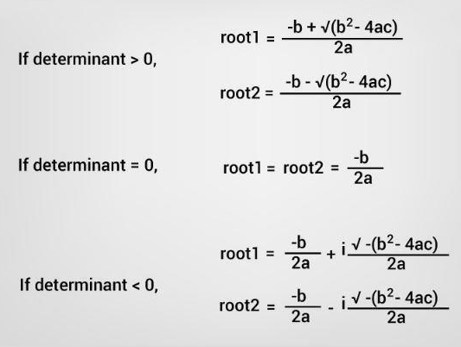

#include<stdio.h>

#include<math.h>

void main( )

{
float a, b, c, root1, root2, rpart, ipart, disc; printf("Enter the 3 coefficients:\n”); scanf(%f%f%f", &a, &b, &c);
if((a*b*c) = = 0)

{
printf("Roots cannot be Determined:\n");

exit(0);

}

disc=(b*b) - (4*a*c);

if(disc == 0)

{
printf("Roots are equal\n"); root1= -b / (2*a); root2=root1;
printf ("root1 = %f \n", root1);

printf ("root2 = %f \n", root2);

}

else if(disc>0)

{
printf("Roots are real and distinct\n");

root1= (-b + sqrt(disc)) / (2*a); root2= (-b - sqrt(disc)) / (2*a); printf ("root1 = %f \n", root1); printf ("root2 = %f \n", root2);
}

else

{

printf("Roots are complex\n");

rpart = -b / (2*a);

ipart = (sqrt (-disc)) / (2*a);

printf("root1 = %f + i %f \n", rpart, ipart);

printf("root2 = %f - i %f \n", rpart, ipart);

}

Output

First Run:

Enter the 3 coefficients:

1

2

1

Roots are equal

Root1= -1.000000

Root2= -1.000000

Second Run:

Enter the 3 coefficients:

2

3

2

Roots are real and equal

Root1=-0.500000

Root2=-2.000000

Third Run:

Enter the 3 coefficients:

2

2

2

Roots are complex

Root1=-0.500000+i 0.866025

Root2=-0.500000- i 0.866025

Programming examples and Exercises

1. What is the output of following program segment? N=4;

M=3;

for (i=0, j=0; i<=N || j<=M; i++, j++)

{

printf(“I=%d J=%d\n”, i , j);

}

Answer: I=0 J=0

I=1 j=1

I=2 j=2

I=3 j=3

I=4 j=4

2. What is the value of k when loop completes in following code?
k=1;

while(++k <=n)

{

printf(“%d”, k);

}

a. n+1 b. n-1 c. n+2
d. n

Answer: n
Suppose if n=2,

Value printed is: 2

3. for( i=1,j=3; i<3;i++,j--)
printf(“i=%d, j=%d”, i,j)

Output is:

Round-1: i=1, j=3

4. sum=0
for(n=1; n!=10; n+=2)

sum = sum+n;

Output is:

Round-1: n=1, 1!=10 is true sum=1
Round-2 n=3, 3!=10 is true sum=4
Round-3 n=5, 5!=10 is true sum=9
Round-4 n=7, 7!=10 is true

sum=16

5. what is the output of this segment?
int x=5, y=50;

while(x<=y)

{

x=y/x;

}
output:

round-1: x=50/5 is 10 round-2:x=50/10 is 5 so, x will toggle between 10 &5 and this loop goes on infinitely as x<=y is always true!
6. Write for statement to print following sequences:
1,2,4,8,16,32
-4,-2,0,2,4
Ans:for( i=1; i<=32; i=i*2)
printf(“%d”, i);
for(i=-4; i<=4; i=i+2)

